**CS403 Assignment #2 Spring 2022**

***Name: Abdul Rehman.***

***VU-ID: BC200403287.***

**Question:**

Our Second assignment is the continuation of our First assignment.

The solution of the First assignment, i.e., the Entity relationship diagram is given below. This ERD will serve as an input to solve the second assignment.

**Entity Relationship diagram (solution of First assignment):**

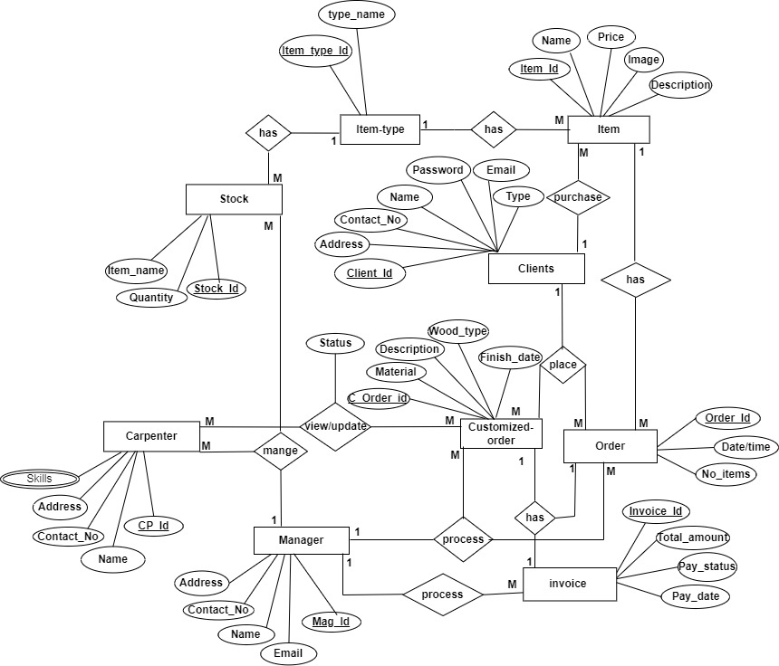

**You are now required to perform the following tasks by considering the above given ER diagram.**

1. **Map the ER diagram to Relational Data Model and link the relations through primary keys and foreign keys.**

**Solution:**

Website I used to draw: <https://app.diagrams.net/>

Please Zoom in for better understanding.

**Screenshots:**

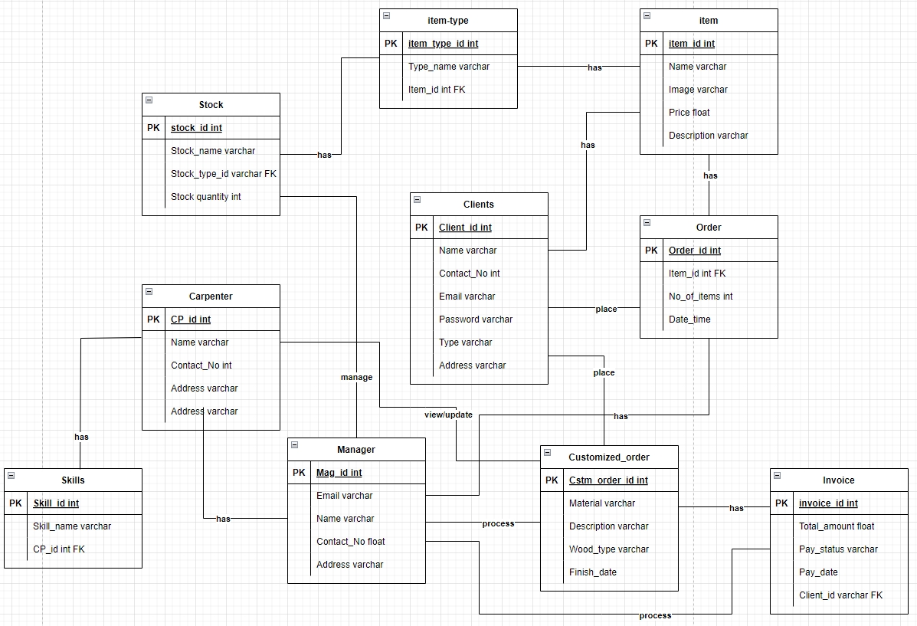

**JPEG File:**

Please Zoom in for better understanding.

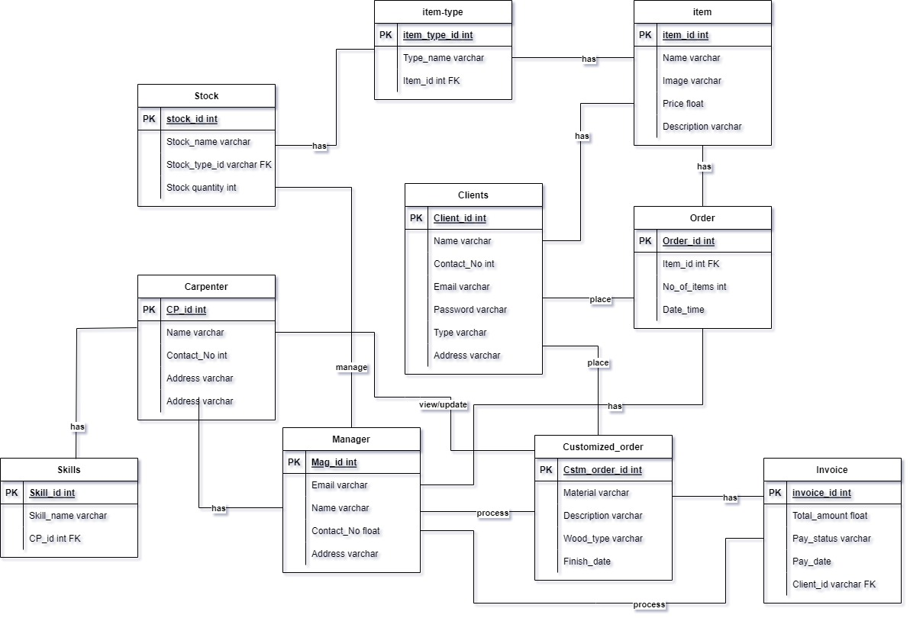

1. **After mapping ERD to Relational Data Model, you are required to write the SQL commands for each of the following statements.**

**Solution:**

|  |  |
| --- | --- |
| **Statement** | **Command** |
| 1. Create a table named **Carpenter**. You also have to define primary key and foreign key (if any). | CREATE table **Carpenter**  (  CP_Id varchar (15) Primary Key,  Name varchar (50),  Address varchar (50),  Contact_No int (50)  ); |
| 1. Change the name of column from **Total_amount** to N**et_payable** in **invoice** table. | ALTER Table **invoice** Rename column **Total_amount** to **Net_payable**; |
| 1. Insert one record in **manager** table having data against each column (Mag_Id: MG01, Email: [ahmad@gmail.com,](mailto:ahmad@gmail.com,) Name: Ahmad, Contact_No: 03001234567, Address: H#4 street abc). | INSERT into **manager** (Mag Id, Email, Name, Contact_No, Address) Values (‘MG01’, ‘[ahmad@gmail.com](mailto:ahmad@gmail.com)’, ‘Ahmad’, ‘03001234567’, H#4 street abc’); |
| 1. Show the Name, Description and images of those Items whose Prices are between 2,000 to 10,000 from **Item** table. | SELECT Name, Description and images of **Items** where Prices are between 2000 and 10000; |
| 1. What is the maximum Quantity for each item_name in **Stock** table. | SELECT MAX(Quantity) from **Stock** Group by Item_name; |